Report HW 7 ECE-111
Name: Jasper Huang
PID: A17796149

Homework 7a

SystemVerilog Design Code Snapshot – uart_rx
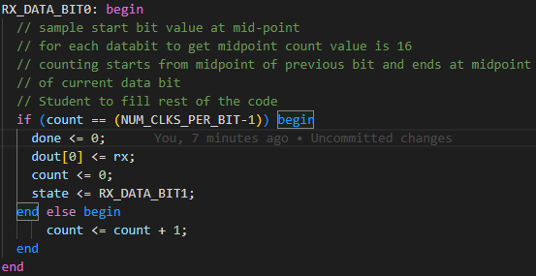
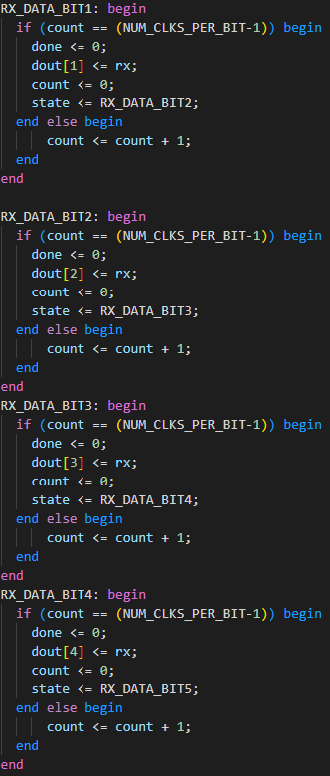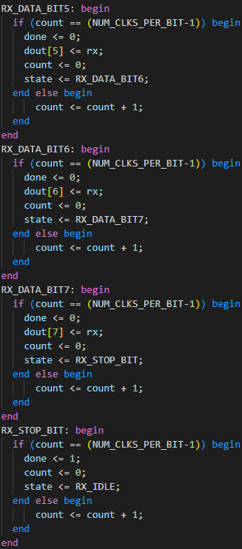

Synthesis Resource Usage – uart_rx
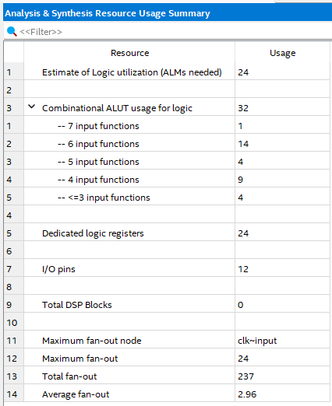

Simulation Snapshot and Result Explanation – uart_rx
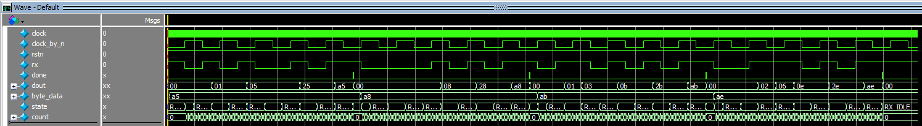
This simulation wave shows the rx receiving the data from rx and changes state between reading each bit from state RX_DATA_BIT0 to RX_DATA_BIT7 to read each bit and combine to dout which then high the done flag to indicate that the data output is ready. The data output a5 a8 ab ae are all correct output based on the input rx.

Modelsim Transcript Window – uart_rx
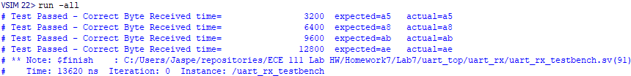

FSM State Transition Diagram and Table – uart_rx
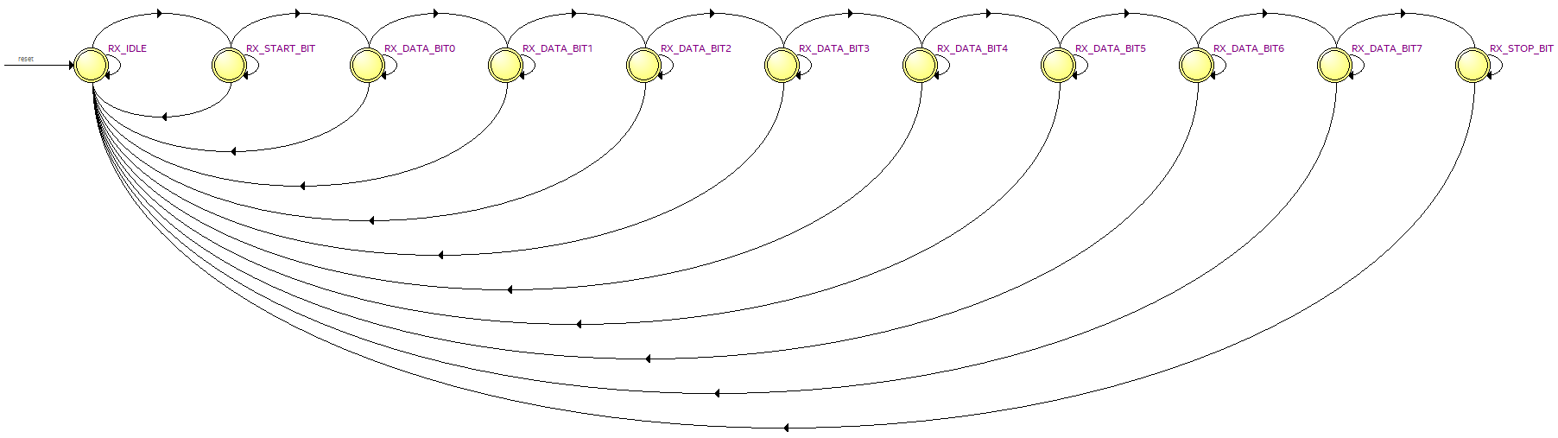
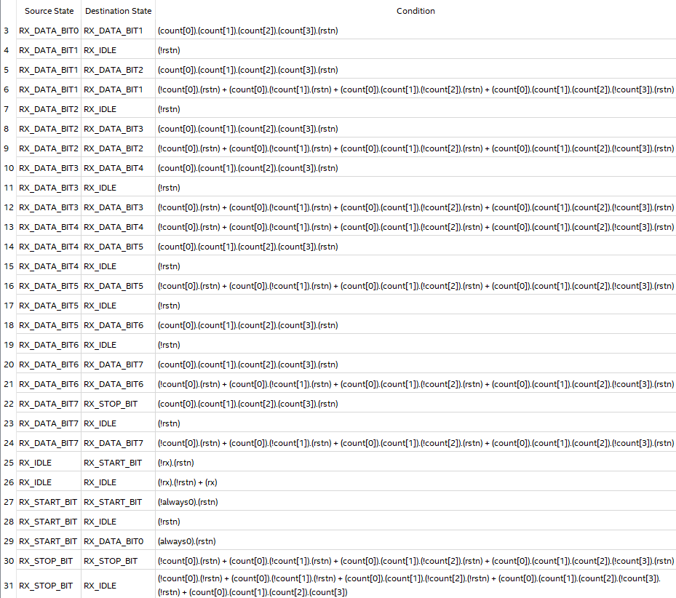

Homework 7b

SystemVerilog Design Code Snapshot – uart_top
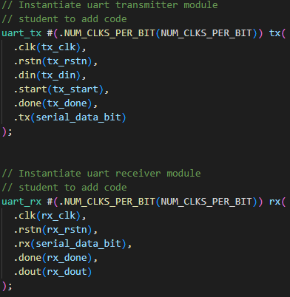

Synthesis Resource Usage – uart_top
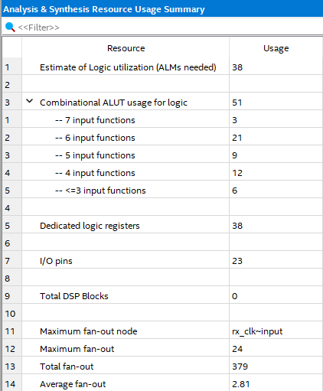

Simulation Snapshot and Result Explanation – uart_top
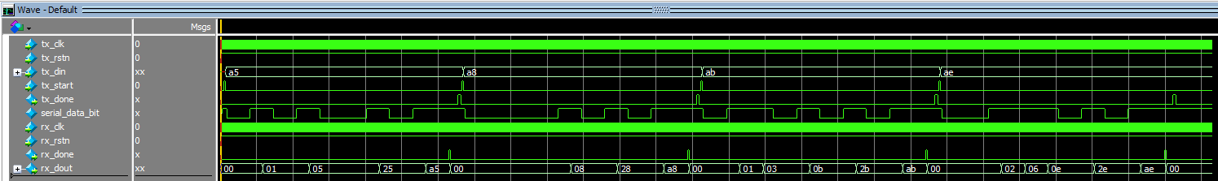
The simulation wave shows the data transmitted from tx to rx for four different values. Each of the four values are first updated in din and start the tx. The data is then transmitted through the serial_data_bit to rx and then the rx_done flag is up once the dout is ready. From the wave, all data is transmitted correctly from tx to rx.

Modelsim Transcript Window – uart_top
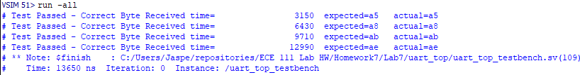

Homework 7c

SystemVerilog Design Code Snapshot – uart_control_system
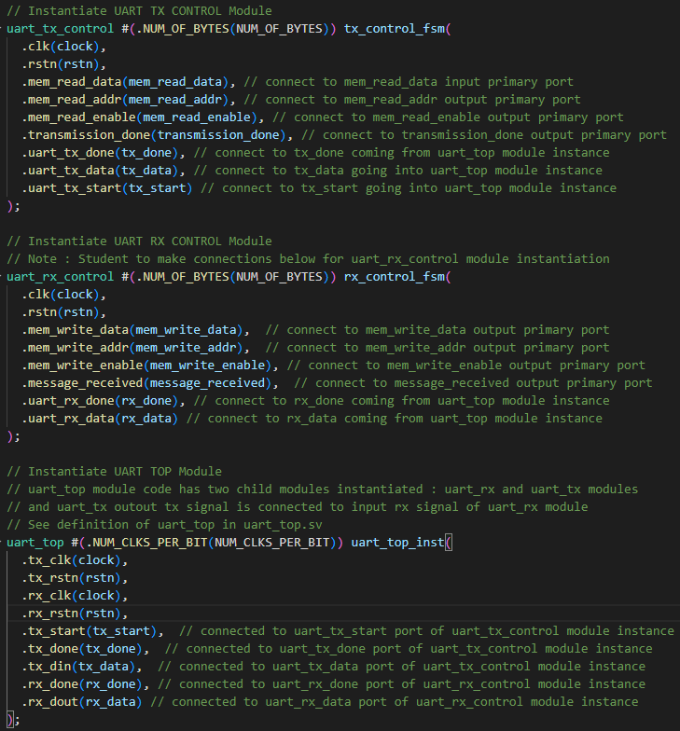

Synthesis Resource Usage – uart_control_system
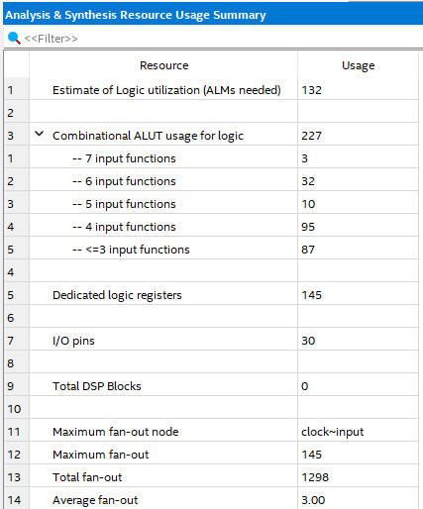

Simulation Snapshot and Result Explanation – uart_control_system
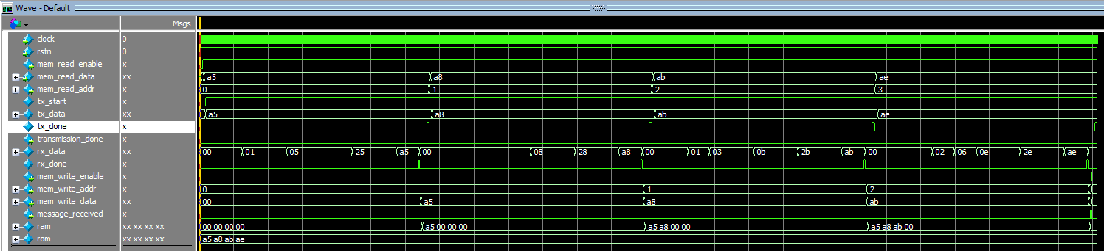
From the wave, the data is first read into mem_read_data, it’s then got the first available data and then transmitted through uart to mem write, which you can see that the rom contains the original information and ram is updated based on the transmitted data through uart and write into the ram. All four data are correctly transmitted.

Modelsim Transcript Window – uart_control_system
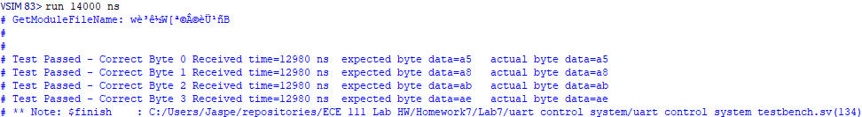

FSM State Transition Diagram and Table – uart_rx_control
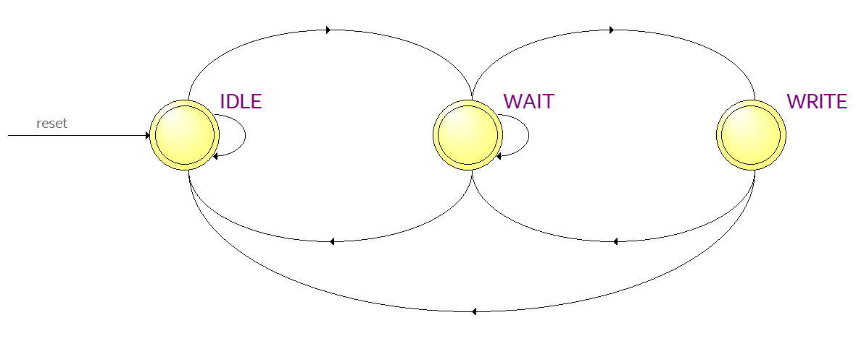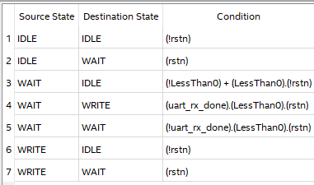

FSM State Transition Diagram and Table – uart_tx_control
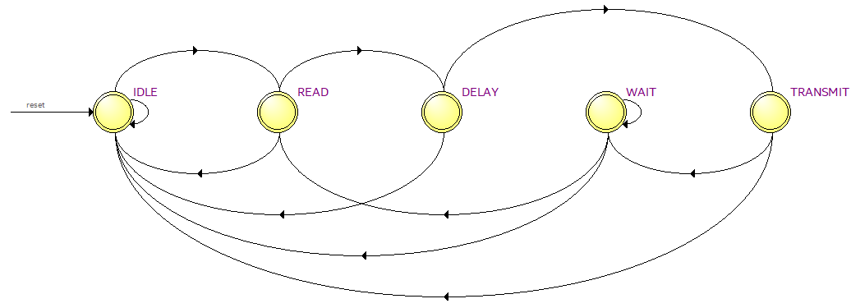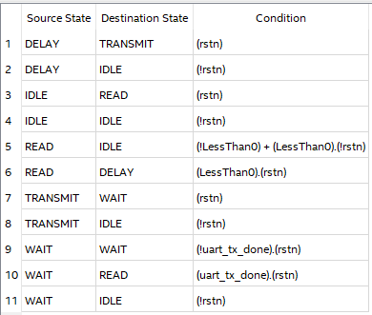

Homework 7d

SystemVerilog Design Code Snapshot – vending_machine_moore_reduced_state
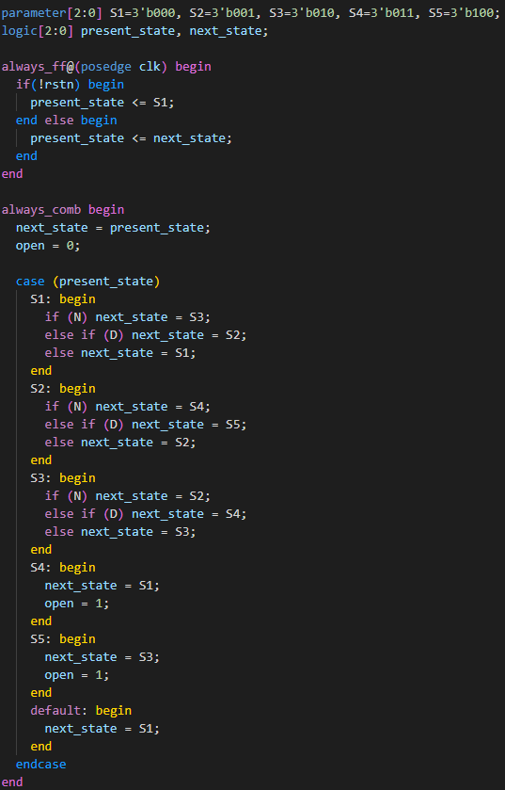

Simulation Waveform Snapshot – vending_machine_moore_reduced_state
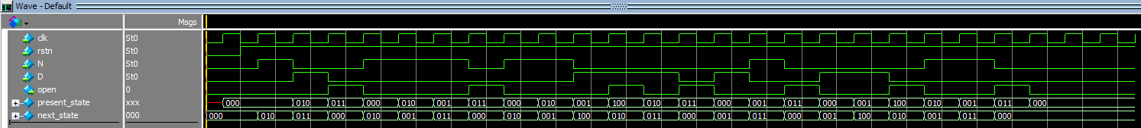

Implication Chart Snapshot – vending_machine_moore_reduced_state
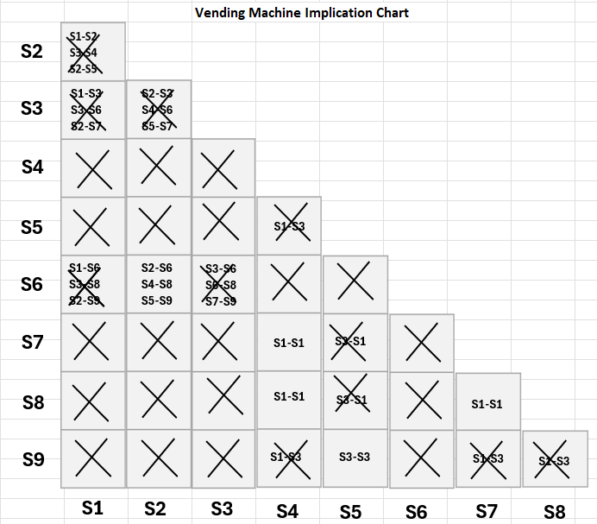

Reduced State Transition Table – vending_machine_moore_reduced_state
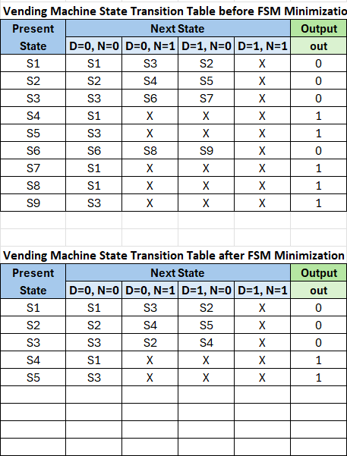

RTL Post Netlist Viewer – vending_machine_moore_reduced_state
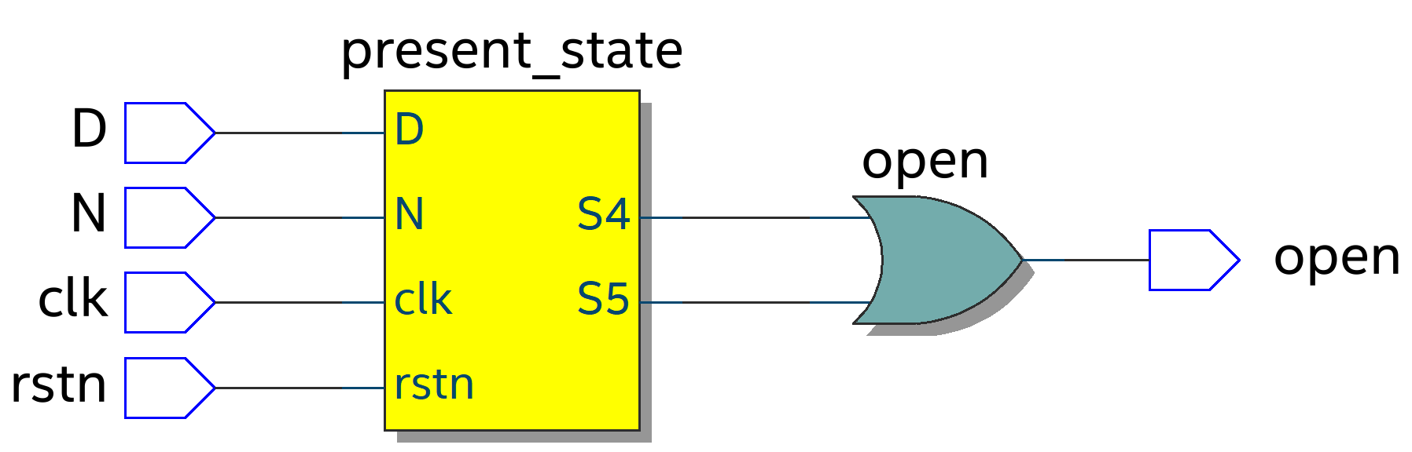

Resource Usage Table– vending_machine_moore_reduced_state
